A000-US-Mass Bay- Seventeenth century carved oak box-17th c

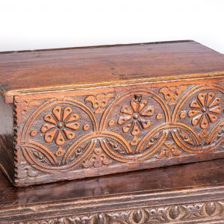

Seventeenth century carved oak box, the front carved with opposing double S-scrolls and each side with lozenge designs, the square top with punch decoration.

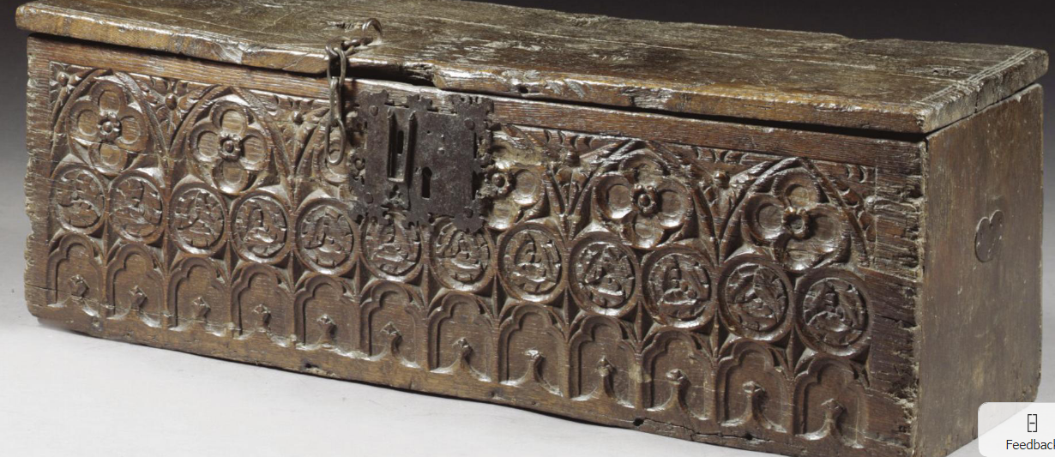

A RARE BOARDED CHEST, GOTHIC, 15TH/16TH CENTURY oak, the front carved with blind tracery, quatrefoils and roundels, the sides with traces of former carrying handles h.38.5cm., w.113cm., d.41cm.

A rare boarded chest, Gothic, 15th/16th century

**Estimate**  2,000 — 3,000[GBP](http://www.sothebys.com/en/auctions/ecatalogue/2007/the-oak-and-country-sale-w07803/lot.48.html)

**LOT SOLD.** 6,000 GBP **(Hammer Price with Buyer's Premium)**